COURSE NAME: Theory of Computation COURSE CODE: CSA1304

COURSE OUTCOME COVERED

CO5: Design Pushdown Automata and analyze their equivalence with Context-Free Grammars through formal construction and proof techniques. ( BL: 3)

Assessment Tool Weightage: 20%

QUESTIONS: 5 Total Marks:25
Duration : 1 Hour
Design Critique Session

Code of Conduct:

I SRIVARSHA M -192371010(Name / Reg No) certify that this submission is my original work and that I have adhered to the guidelines specified for this assessment.
I understand that any violation of academic integrity rules will result in disciplinary action.

Signature of the student:
SRIVARSHA M

- A PDA is designed to recognize a^nb^n, but it fails for a^nb^nC^n. Critique the design and identify possible flaws in stack operations and state transitions. How would you improve it?

- A student claims that Context-Free Grammars (CFGs) .
E → E + T | T
T → T * F | F F → ( E ) | id
can be directly converted into a Deterministic PDA (DPDA).Critically evaluate
this statement with justification and suggest corrections if needed

- A Turing Machine is designed using multiple tracks to solve a problem. Suggest alternative programming techniques like checking-off symbols or subroutines to do subtraction
- While designing a PDA accepts the language
𝐿 = {𝑤 | 𝑤 ∈ (𝑎 + 𝑏) ∗ 𝑎𝑛𝑑 𝑛_{𝑎}(𝑤) == 𝑛_{𝑏}(𝑤) }
𝑛𝑎(𝑤) is the number of a’s in w
𝑛_{𝑏}(𝑤) is the number of b’s in w, acceptance is defined only by final state, ignoring empty stack acceptance. Critique this design choice. Would it affect the language recognized? Explain with reasoning.
- A system designer suggests replacing a Turing Machine with a PDA to reduce computational complexity. Critically compare FA, PDA, and Turing Machine capabilities and evaluate whether this replacement is valid.

- A PDA is designed to recognize a^nb^n, but it fails for a^nb^nC^n. Critique the design and identify possible flaws in stack operations and state transitions. How would you improve it?

Critique of the PDA for
A PDA can correctly recognize the language
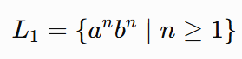
because it has a stack to remember the number of a's.
For example, while reading a's, it pushes one symbol for every a:
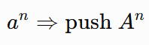
Then, while reading b's, it pops one A for every b:
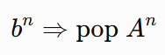
When the stack becomes empty, the PDA knows that the number of a's and b's is equal.
Why it fails for a^nb^nc^n
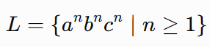
Consider:
The PDA can perform the first two comparisons:
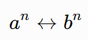
by pushing A's for every a and popping them for every b. However, after reading all b's, the stack is empty.
For example, for
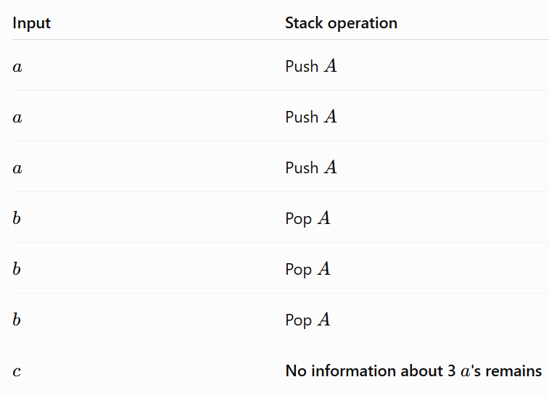
aaabbbccc the operations are:

Therefore, the PDA cannot compare the number of c's with the original number of a's.

Possible flaws
- Incorrect stack popping:
If the PDA pops all A's while reading b's, there is nothing left to compare with the c's.

Missing -state transitions:
The PDA may have no valid transition for c once the stack becomes empty.

Trying to reuse the same stack:
If the PDA pushes symbols again while reading b's, it loses the information needed to verify that the number of a's and b's were equal.

Incorrect acceptance condition:
Simply reaching the c-state or emptying the stack does not guarantee
#a=#b=#c.

How can we improve it?
A single-stack PDA cannot recognize
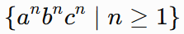
because this language is not context-free.
A single PDA can remember one equality, such as
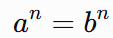
but it cannot simultaneously remember the original number of a's while also checking
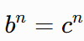
To handle a^nb^nc^n, we would need a more powerful model, such as a two-stack PDA, which is equivalent in computational power to a Turing Machine.

Improved approach using two stacks
- Stack 1: Push one symbol for every a.
- Read 's and pop Stack 1 → verifies a^n=b^n.
- At the same time, push one symbol into Stack 2 for every b.
- Read 's and pop Stack 2 → verifies b^n=c^n.
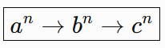
- Accept only if both stacks are properly emptied and the input ends. Thus:

is checked as
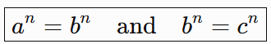

- A student claims that Context-Free Grammars (CFGs) E → E + T | T
T → T * F | F F → ( E ) | id

can be directly converted into a Deterministic PDA (DPDA).Critically evaluate this statement with justification and suggest corrections if needed
Given CFG
E → E + T | T
T → T * F | F F → ( E ) | id
This grammar represents arithmetic expressions containing +, *, parentheses, and identifiers.
- CFG → PDA
Every context-free grammar can be converted into an equivalent nondeterministic PDA (NPDA). The usual construction is:
  - Put the start variable E on the stack.
  - If the top of stack is a variable, replace it using one of its productions.
  - If the top of stack is a terminal, match it with the input symbol and pop it.
  - Accept when the entire input has been consumed and the stack is empty.

For example, because
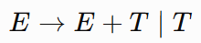
the PDA must choose between and E + T and T. This choice is generally nondeterministic.

Why direct conversion to DPDA is problematic
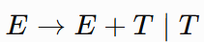
A DPDA cannot freely make nondeterministic choices. In the given grammar, productions such as
And
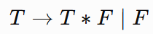

create choices. A standard CFG-to-PDA construction therefore produces an NPDA, not a DPDA. Also, the grammar is left-recursive:

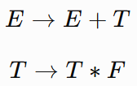

Left recursion is inconvenient for constructing a predictive deterministic parser.

Important correction
The correct statement is:
Every CFG can be converted to an equivalent NPDA, but not every CFG can be directly converted to a DPDA.
There is also an important theoretical point: not every context-free language is deterministic context-free. Therefore, an arbitrary CFG cannot simply be assumed to have an equivalent DPDA.
However, this particular grammar describes a conventional arithmetic-expression language, which can be parsed deterministically after suitable transformation.

How to correct the grammar
Remove left recursion. For example:
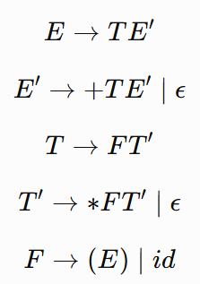

Now the grammar is suitable for predictive/deterministic parsing because the left recursion has been removed.

Conclusion
The student's claim is incorrect as stated. The standard direct conversion of a CFG gives an NPDA, not necessarily a DPDA. For this grammar, left recursion should first be removed, producing a grammar
suitable for deterministic parsing.

A Turing Machine is designed using multiple tracks to solve a problem. Suggest alternative programming techniques like checking-off symbols or subroutines to do subtraction

Alternative techniques for subtraction in a Turing Machine
If a Turing Machine uses multiple tracks to perform subtraction, the same problem can be solved using simpler single-tape techniques. Two useful techniques are:

Checking-off symbols
The Turing Machine can mark symbols that have already been processed. For example, to compute:
5−3
Represent the numbers as:
11111−111
The machine can repeatedly:
  - Find an unmarked 1 in the second number.
  - Mark it as X.
  - Move to the first number and mark one 1 as X.
  - Repeat until all 1s in the second number are marked.
  - The remaining unmarked 1s in the first number represent the result. Thus:
11111−111→11
So the result is:
5−3=2
Advantage: It is simple and does not require multiple tracks.

Using subroutines
Instead of designing one large Turing Machine, the subtraction operation can be divided into smaller reusable subroutines.
For example:
- Subroutine 1: Find the next unmarked symbol.
- Subroutine 2: Mark the selected symbol.
- Subroutine 3: Move to the other number.
- Subroutine 4: Match and cancel one symbol.
- Subroutine 5: Check whether subtraction is complete.
- Subroutine 6: Clean up the tape and produce the final answer.

The main machine calls these subroutines whenever required.

Advantage: The design becomes easier to understand, debug, and modify.

Conclusion
Therefore, instead of using multiple tracks, subtraction in a Turing Machine can be implemented using checking-off symbols and subroutines. Checking-off is useful for matching and cancelling symbols, while subroutines divide the computation into smaller reusable operations. These techniques make the Turing Machine simpler and more systematic.
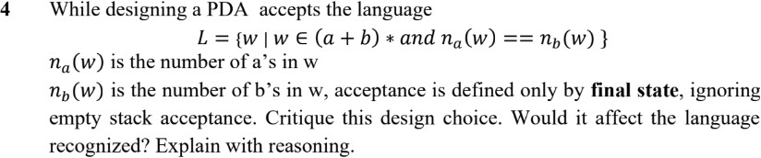
The design choice should be critically evaluated, because accepting only by final state is not automatically equivalent to accepting by empty stack for a particular PDA.

Given language
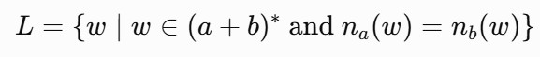

where:
- na(w)= number of as in w
- nb(w)= number of bs in w Examples:
ϵ, ab, ba, aabb, abab, abba
are in L, because the number of as equals the number of bs. But:
a, abb, aaab
are not in .

Acceptance by final state
If the PDA is defined to accept only by final state, then the machine must ensure that:
- The entire input has been consumed, and
- The stack represents equal numbers of as and bs, and
- The PDA enters the final state only after these conditions are satisfied. For example, the PDA can use its stack to cancel opposite symbols:

  - When reading a, push A if the current excess is a.
  - When reading b, pop A if possible.
  - Similarly, it can use another stack symbol to handle an excess of b.
When the input ends and the stack is back at the bottom marker, the PDA enters the final state.

Why ignoring empty-stack acceptance can be a problem
If the PDA is designed carelessly, it might enter a final state before the input is completely consumed. For example, suppose the machine reaches a final state after processing:
ab
Since has equal numbers of a and b, this is correct only if there is no remaining input. If the remaining input is a, then the complete string is:
Aba
And
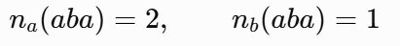
so it must not be accepted.
Therefore, simply reaching a final state is insufficient; the PDA must ensure that the input is completely read.
Does final-state acceptance change the language? No, if the PDA is designed correctly.
For nondeterministic PDAs, acceptance by final state and acceptance by empty stack are equivalent in expressive power. Both can recognize exactly the class of context-free languages.
Thus, for this language, using final-state acceptance does not change the recognized language, provided the PDA is constructed properly.
However, the particular PDA's behavior can change if the final-state condition is implemented incorrectly.

Conclusion
The PDA must enter the final state only after the entire input is consumed and the stack indicates equal numbers of as and bs. Empty-stack acceptance would provide a more direct way to express the condition, but it is not necessary because final-state and empty-stack acceptance are equivalent for NPDAs.

5.A system designer suggests replacing a Turing Machine with a PDA to reduce computational complexity. Critically compare FA, PDA, and Turing Machine capabilities and evaluate whether this replacement is valid.

Comparison of FA, PDA, and Turing Machine
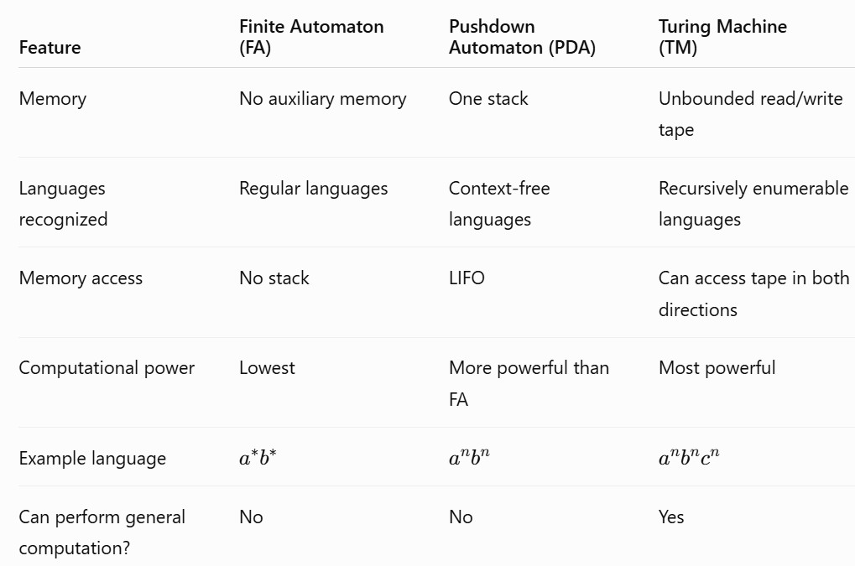

Finite Automaton
An FA has only a finite number of states and no additional memory. For example:

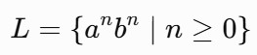
can be recognized by an FA. However, an FA cannot recognize:

because it cannot remember an arbitrary number of as.

Pushdown Automaton
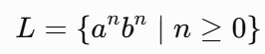
A PDA has a stack, so it has more memory than an FA. For example:

can be recognized by a PDA.
The PDA pushes a symbol for every a and pops one symbol for every b. However, a single stack has limitations. For example,

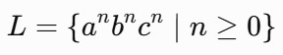
is not context-free, so it cannot be recognized by a standard PDA.

Turing Machine
A TM has an unbounded read/write tape. It can move left or right and modify symbols already written on the tape.
It can recognize languages such as:
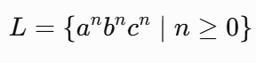
and can perform much more general computations.
A Turing Machine is therefore much more powerful than a PDA.

Is replacing the TM with a PDA valid?
Not in general.
If the problem only requires context-free language processing, such as:
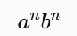

then using a PDA may be appropriate and can provide a simpler computational model.
But if the problem requires the computational power of a TM, replacing it with a PDA will make some problems unrecognizable.
For example:
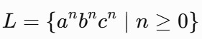

can be handled by a TM but not by a PDA. Important point about complexity
A PDA is not automatically better simply because it is less powerful. Reducing the computational model may reduce resources for a particular problem, but it can also make the problem impossible to solve.
Conclusion: The system designer's proposal is valid only when the problem is known to require no more than PDA-level computational power. Replacing a TM with a PDA in general is not valid,
because a PDA cannot perform every computation that a Turing Machine can.

RUBRICS FOR CALCULATION

Criteria | Weightage | Level 4 –  Exemplary (5 Marks) | Level 3 –  Proficient (4 Marks) | Level 2 –  Developing (2–3 Marks) | Level 1 –  Beginning (0–  1 Mark)
Conceptual Understanding | 30 | Demonstrates clear and complete understanding of  the concept | Good understanding with minor gaps | Basic understanding with some  misconceptions | Poor or incorrect understanding
Accuracy of Answer | 25 | Completely correct answer with no  errors | Mostly correct with minor  errors | Partially correct with noticeable  errors | Incorrect or irrelevant  answer
Application of Knowledge | 20 | Correctly applies concepts to solve the  question/problem | Applies concepts with minor mistakes | Limited or partially correct application | No or incorrect application
Completeness of Response | 15 | Covers all required  parts of the question | Covers most  parts with minor omissions | Covers only some parts | Incomplete or  missing response
Clarity & Presentation | 10 | Clear, concise, and well-organized  answer | Understandable with minor  issues | Somewhat unclear or poorly  structured | Difficult to understand

